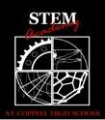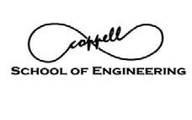

COPPELL HIGH SCHOOL ENGINEERING EXPO 2016 SATURDAY, APRIL 2, 2016
185 W. PARKWAY BLVD., COPPELL TX 75019

SAT, APRIL. 2ND 1:00 – 1:45 PM
EXHIBITOR AGENDA

EXHIBITOR SET UP PERIOD
EXHIBITOR ENTRANCE – CHS REAR ENTRANCE (TEACHER LOT)
CHS STEM Academy and School of Engineering (SOE) students, parent volunteers and CHS Red Jackets will be available to help Exhibitors set up exhibits and displays.

1:15 – 5:00 PM Hospitality Room Open to Exhibitors

2:00 – 5:00 PM Engineering EXPO open to the public
3:00 PM KEYNOTE SPEAKER

Remember your audience: primarily 7th – 12th grade students (mainly high school students). Remember your #1 goal – get more students interested in pursuing an engineering degree!

NOTES:

- Exhibitors must be ready for doors to open for guests at 2:00 PM
- Electrical outlets are available at ALL Exhibitors’ tables. Wireless internet access is available.
- There is no charge for Exhibitors tables.
- Hospitality Room for Exhibitors ONLY offers complimentary water, coffee, soft drinks and snacks will be available throughout the EXPO.

PLEASE CHECK OUR WEBSITE FOR MORE INFORMATION AND UPDATES:
http://www.chsengineeringboosters.com/engineering-expo.html

